Kew Medical Practice

PERSONAL DETAILS
Surname: |  |  | Date of Birth:
Forenames: |  |  | Marital status:
Gender:
Address:
Postcode: |  | Tel No:  (11 digits) |  | (home)  (work)  (mobile)
Email:
Occupation: |  | First Language:
Emergency contact name & number:
Please state relationship to you (if any)

Are you a new or returning patient (please tick):
Do you want to be set up with online access for booking appointments, requesting medication and able to view medical history? (Circle) YES NO

PATIENT PARTICIPATION GROUP
Would you be interested in taking part in our virtual Patient Participation Group and receive occasional surveys regarding your thoughts about the practice? | (Circle)  YES NO
Email Address:
So we can keep in touch with you

LIFESTYLE
How often do you exercise for 20 mins at a time?
What type of exercise is it?

Are you a carer? | (Circle)  YES NO
Are you a formal or informal carer? | (Circle)  Formal Informal

What is your height (centimetres / cm)? | What is your weight (Kilograms / kg)?
Blood Pressure Readings ( / )

MEDICAL DETAILS
Do you suffer/have you suffered in the past from any of the following?
Condition | Date of Diagnosis | Do you still suffer from this?  Yes / No
Asthma
High Blood Pressure
Diabetes
Cancer (state type)
Epilepsy
Chronic Obstructive Pulmonary Disease (COPD)
Please list any other known conditions:

Please list all medicines you use regularly:
Medicine | Dose per day

Have you ever been in hospital for anything? Please state when and for what.
Have you ever had any medical problems / illnesses you have had to see your doctor regularly about? Give details, including dates.

Are you allergic to any medicines or other substances (e.g. pollen, nuts)?
FAMILY HISTORY
Is there a history of any of the following in your family? Tick and state age at time of diagnosis:
 | Mother | Father | Aunt | Uncle | Grand  mother | Grand  father | Sister | Brother
Heart Attack
Diabetes
Stroke
Asthma
High Blood Pressure
Cancer (state type)

ETHNIC ORIGIN
Since 1 April 2006 the practice has been required to collect ethnicity data on all patients. Under the Race Relations Amendment Act 2000 and Fair For All policy initiatives we have an obligation to promote racial equality and reduce ethnic inequalities in health. NHS organisations therefore have a particular responsibility to monitor the effects of health policy on different ethnic groups.

The information we collect will be used only for this purpose and will be treated in the strictest confidence.

Please note: we are not asking about your nationality or citizenship, but about the ethnic group you feel you belong to.

Please indicate your ethnic origin. This is not compulsory, but may help with your healthcare, as some conditions are more common in specific communities, so this information could help with early identification of some conditions. The groups below are as defined in the 2001 census.

White background: |  | Black background:
British or mixed British |  | Caribbean
Irish |  | African
Other |  | Other
Asian background: |  | White and Black background:
Indian |  | White and Black African
Pakistani |  | White and Black Caribbean
Bangladeshi |  | White and Asian
Other |  | Other mixed background
Chinese |  | Other
Ethnic category refused

Summary Care Records and SMS Opt Out

The SCR is an electronic record of important patient information, created from GP medical records. It can be seen and used by authorized staff in other areas of the health and care system involved in the patient's direct care.

Please indicate your consent for Summary Care Record by ticking on the box.

Express consent for medication, allergies and adverse reactions only
Express consent for medication, allergies and adverse reactions only AND additional information
Express dissent (opted out) – Patient does not want a Summary Care Record

Our clinical system sends automated SMS messages as reminders for appointments. We also use it for invitations for clinical check-ups, invitations and communications for things which might affect you.

Opt out of SMS messaging
WOMEN ONLY SECTION

How many times have you been pregnant?
How many deliveries have you had?
Type (e.g. normal; Caesarean)
If premature, how many weeks?
Any problems? (e.g. raised blood pressure)

What method of contraception are you currently using?

What was the date of your last smear?
What was the result?
NORMAL - routine recall, 3 years |  | ABNORMAL
NORMAL - early recall, 1 year |  | BORDERLINE CHANGES
NORMAL - early recall, 6 months |  | INADEQUATE
If abnormal, are you currently undergoing treatment?
Have you had an abnormal smear in the last 10 years?

I DO NOT REQUIRE CERVICAL SCREENING SERVICES (tick to confirm if this is the case)
Reason screening not required:
If you have had a total hysterectomy please give date (and if possible type e.g. abdominal/ total/ vaginal):

Have you got an IUCD or IUS? (Intrauterine Contraceptive Device, coil or Mirena) Yes / No
If yes, when was it fitted? (month and year)
When it was last checked?
Are you having any problems with it? (bleeding, pain, discharge)
- If you are having problems, please make an appointment with a GP to discuss this.
- IUCD and IUS should be changed or removed after 5 years

KEW MEDICAL PRACTICE

Confidential Smoking Status Questionnaire

Dear Patient or Carer

In order to ensure that we hold the correct details for all of our patients we are asking you to complete this short questionnaire with regard to your smoking status. Once completed please hand it back to the Receptionist.

We are keen to promote our in-house ‘Stop Smoking Clinic’ run by the Practice Nurse and Healthcare Assistant. Therefore, we are asking if you smoke, and if so whether you would like to be offered an appointment to talk with our Stop Smoking advisers.

Alternatively, we can provide you with information on how to access free stop smoking sessions in the community.

Thank you for your assistance.

Kind Regards

Dr. Moj Fitzmaurice

Do you currently smoke? Yes No

If YES how many per day? ………………..

Are you an ex-smoker? Yes No

If YES when did you give up? ____/_____/_______

How many did you smoke per day? ………………….

Have you ever smoked? Yes No

If you wish to stop smoking would you like to be contacted by the Practice with more information on the support available to help you quit?

YES Please contact me with more information

Kew Medical Practice

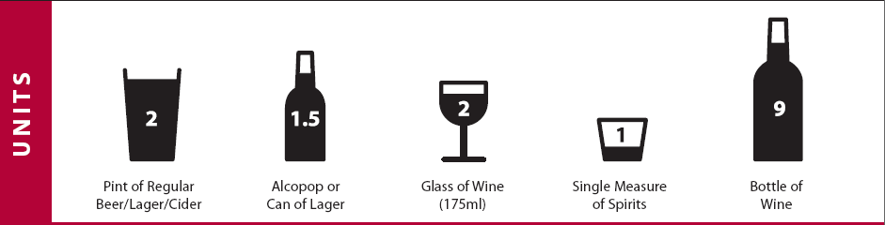
For the following questions please tick the answer which best applies.

Life long teetotaller □  Ex-drinker □  Currently Drinks □ | When did you stop drinking? __/__/____
How often do you have a drink that  contains alcohol? | Never  0 | Monthly or Less  1 | 2 - 4 times per month  2 | 2 - 3 times per week  3 | 4+ times a week  4
How many standard alcoholic drinks  do you have on a typical day when  you are drinking? | 1 - 2  0 | 3 - 4  1 | 5 - 6  2 | 7 - 8  3 | 10 +  4
How often do you have 6 or more  standard drinks on one occasion? | Never  0 | Less than Monthly  1 | Monthly  2 | Weekly  3 | Daily or almost Daily  4
Total for Each Column:
Total:
Scoring: A total of 5+ indicates hazardous or harmful drinking

